IP ROUTING AND ROUTING PROTOCOLS
- Draw a simple network diagram showing three devices (like your phone, a friend's laptop, and a smart TV) connected through a router, and label the IP addresses for each device and the router's interfaces.
Answer
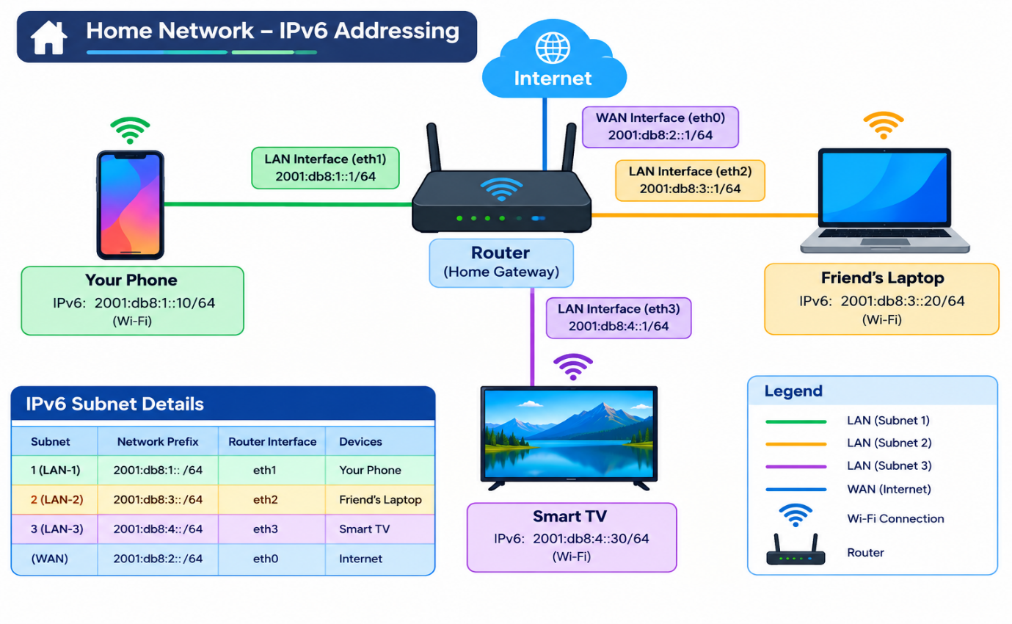
- Simulate manual IP routing by writing a step-by-step explanation of how a packet would travel from your laptop to a friend's computer in a different subnet, including which router(s) it passes through and how the routing decision is made .Use made-up IP addresses and show the routing table entries that would be checked at each hop.
Answer
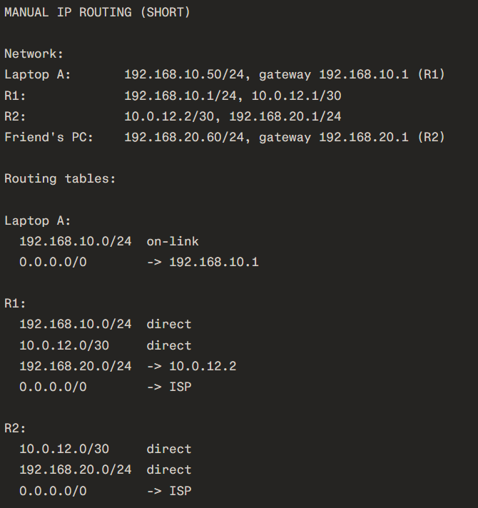
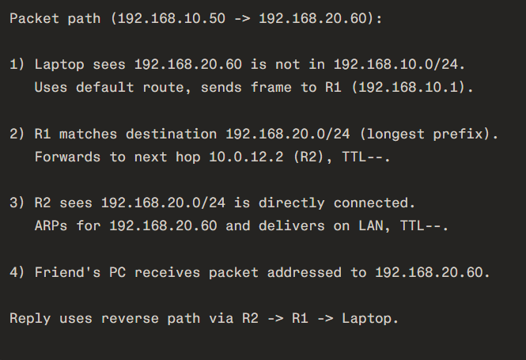
- Create a routing table for a fictional Zomato-style delivery network with three branches in different cities, each on a different subnet. Specify the network address, subnet mask, next hop, and interface for each route.
Answer
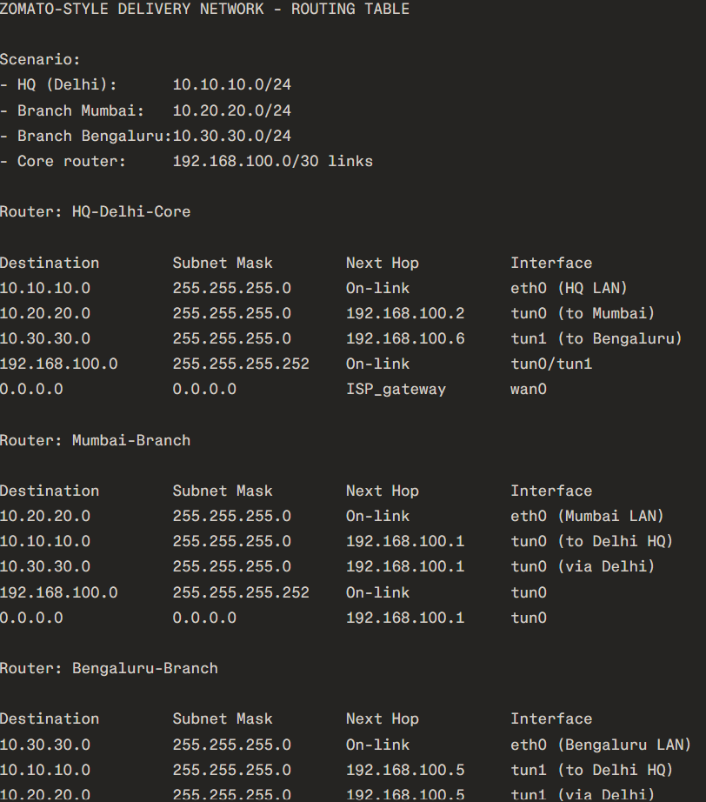
- Compare static routing and dynamic routing protocols (like RIP or OSPF) by listing 3 pros and 3 cons of each, using examples from real-world apps or services you use (e.g., how a food delivery app might benefit from dynamic routing).
Answer
Static vs Dynamic Routing
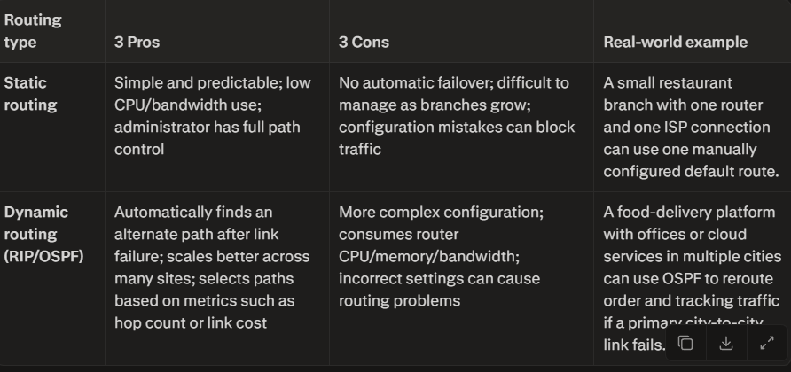
Quick rule: Use static routing for small, stable networks. Use dynamic routing such as OSPF for larger networks with multiple branches, backup links, and high-availability requirements.
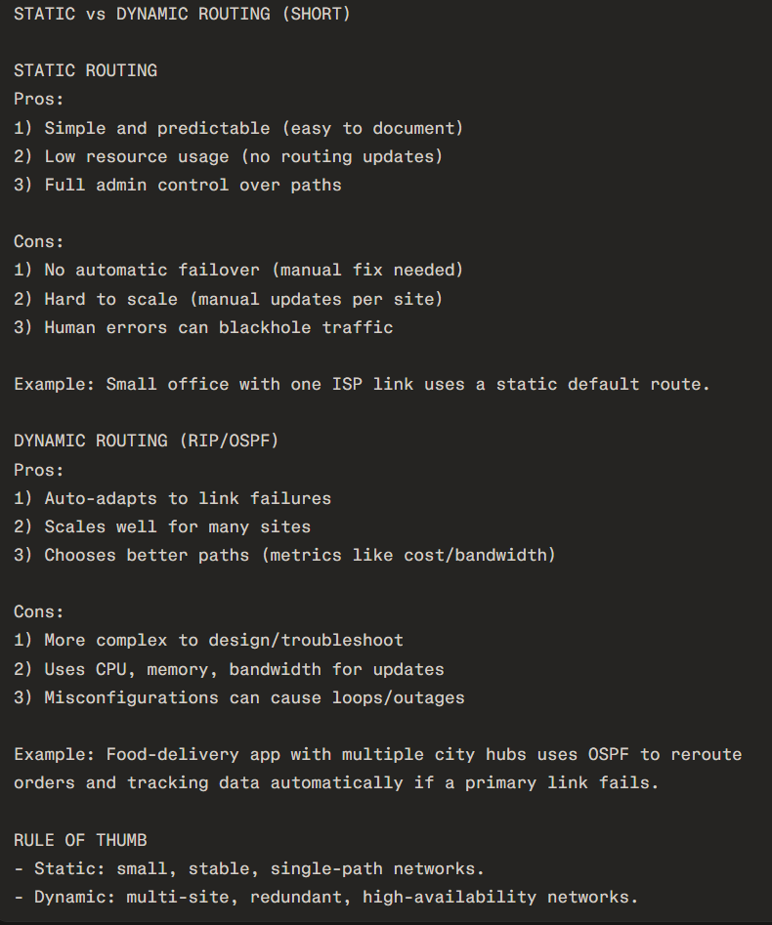

- Use ChatGPT or another AI tool to generate a sample configuration for setting up OSPF routing between two routers, then explain in your own words what each configuration line does. Paste the AI-generated config and annotate each part with a short description.
Answer
